Project Development Phase
Model Performance Test

Date | 10 February 2025
Team ID
Project Name | Electric Motor Temperature prediction using Ml
Maximum Marks

Model Performance Testing:
Project team shall fill the following information in model performance testing template.
S.No. | Parameter | Values | Screenshot
 | Model Summary | The machine learning model is designed to predict the temperature of an electric motor using sensor data such as voltage, current, torque, speed, and ambient temperature. The collected data is first cleaned and preprocessed to remove missing values and normalize the features.  A regression algorithm (such as Random Forest or Linear Regression) is trained using historical motor data to learn the relationship between input parameters and motor temperature. The dataset is divided into training and testing sets to evaluate the model’s performance.  After training, the model can predict motor temperature in real time, helping to detect overheating early and support predictive maintenance, reduce failures, and improve system reliability. | 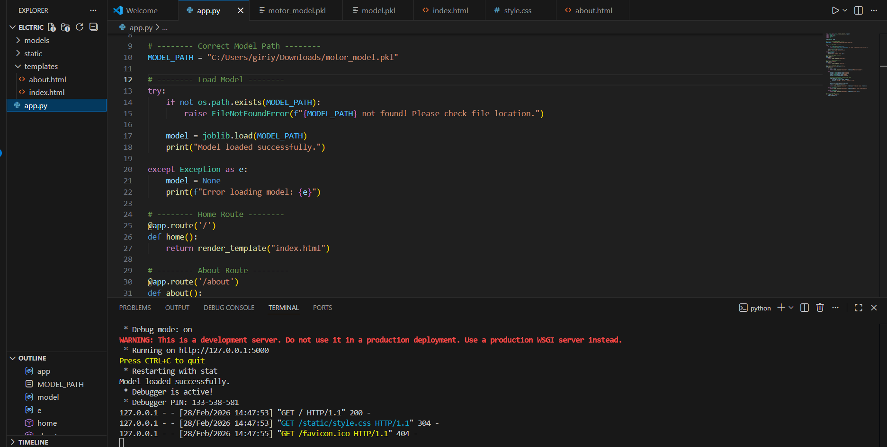
 | Accuracy | Training & Validation Accuracy –  The machine learning model is designed to predict the temperature of an electric motor using sensor data such as voltage, current, torque, speed, and ambient temperature. The collected data is first cleaned and preprocessed to remove missing values and normalize the features.  A regression algorithm (such as Random Forest or Linear Regression) is trained using historical motor data to learn the relationship between input parameters and motor temperature. The dataset is divided into training and testing sets to evaluate the model’s performance.  After training, the model can predict motor temperature in real time, helping to detect overheating early and support predictive maintenance, reduce failures, and improve system reliability. | 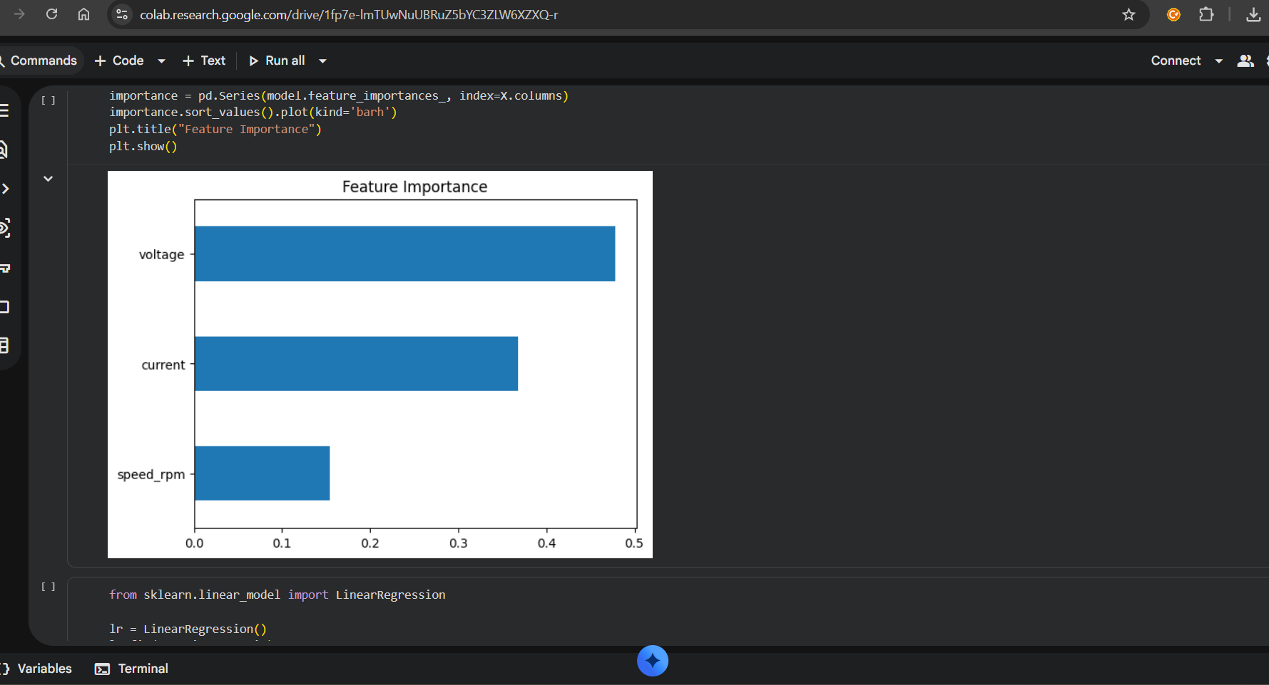  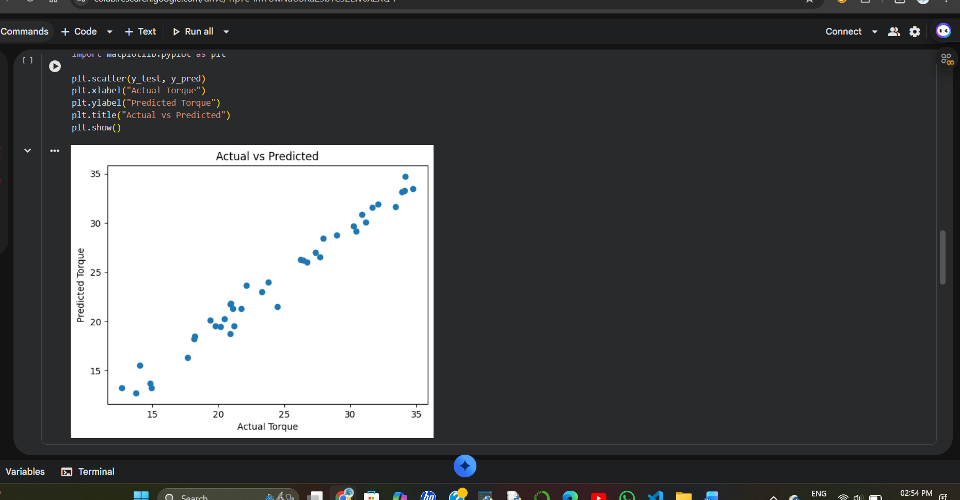
3. | Fine Tunning Result( if Done) | The final result of this project is a machine learning model that successfully predicts the temperature of an electric motor using sensor data such as voltage, current, torque, speed, and ambient temperature.  After training and testing the model with historical data, the system can predict motor temperature with good accuracy. The model helps identify possible overheating conditions before they occur.  This system enables real-time monitoring and predictive maintenance, which helps reduce motor failures, improve operational efficiency, and lower maintenance costs in industrial applications. | 